Drozer Activity and Content Provider Audit with DIVA

# Activities

Check if emulator is connected to the adb by using adb devices

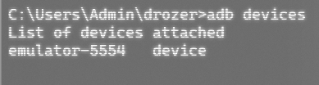

Connect drozer to localhost on the port on which drozer is running

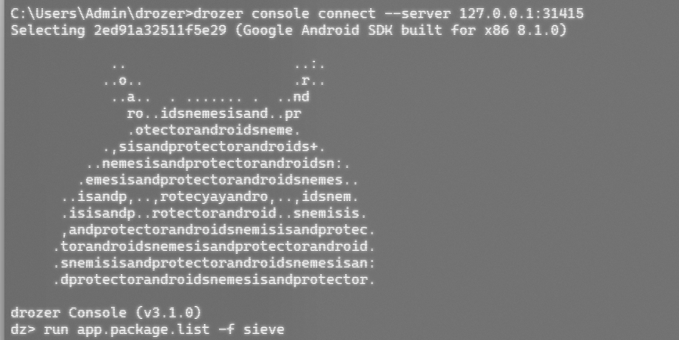

Retrieving package information of DIVA

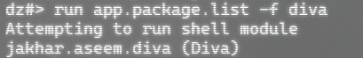

Once we get the path of the target we will identify attack surface of the DIVA application

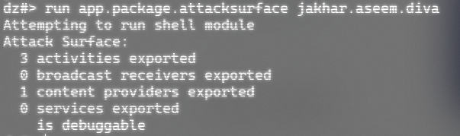

We see that there are 3 activities and 1 content provider that is exported. We can go ahead and retrieve this information using drozer

Listing all activity information

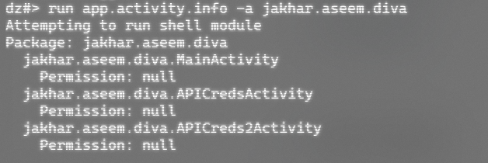

We get all activity paths that we can use to list individually and run them in the emulator

Executing first main activity:



The command executes in the emulator and shows the homepage of DIVA

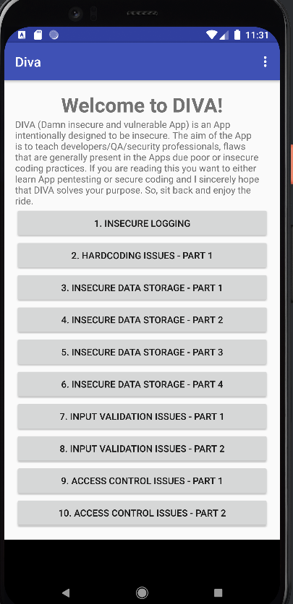

Executing the second activity through CLI

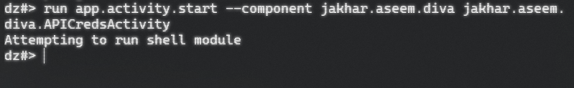

The second activity results in this page

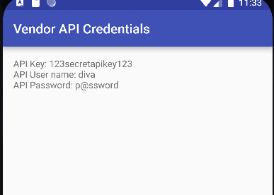

Executing the third activity



The third activity shows the following screen

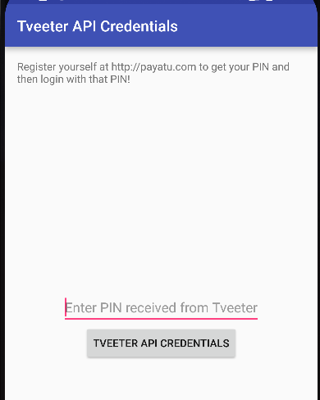

# Content providers

We saw that 1 content provider was also extracted when the packages were retrieved.

We will then retrieve all information of content provider from the application path.

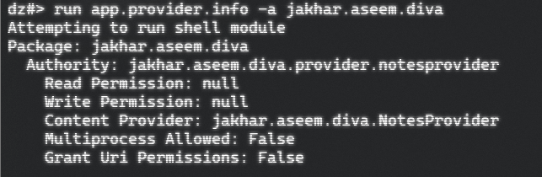

We can get URIs of the content provider 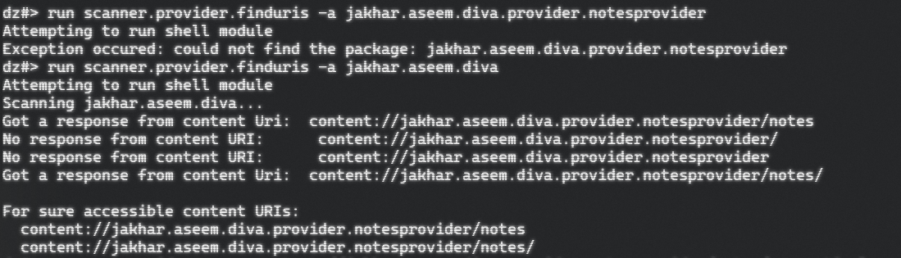

Once we get the URIs we can run those and get the information shared via content providers in DIVA application.